ADAPTIVE SHOES

Plae Shoes  - The top of the shoe is more open since the tongue moves out of the way so the ankle brace is better able to slide into the shoe | 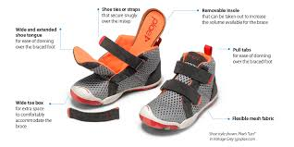 | 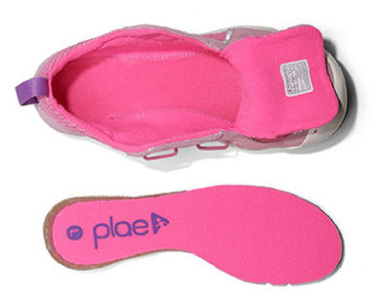
Hatchbacks Footwear  - Heel cup bends down to provide more room to slide the ankle brace into the shoe  - Heel cup Velcros to shoe on both sides | 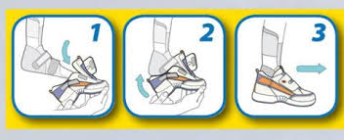
Keeping Pace Shoes  - Heel cup hinges down so the ankle brace can slide into the shoe from the back  - Heel cup Velcros to shoe on both sides | 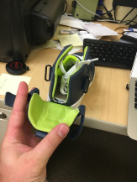 | 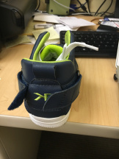
Billy Footwear  - Shoes have a long zipper where the whole top of the shoe hinges open | 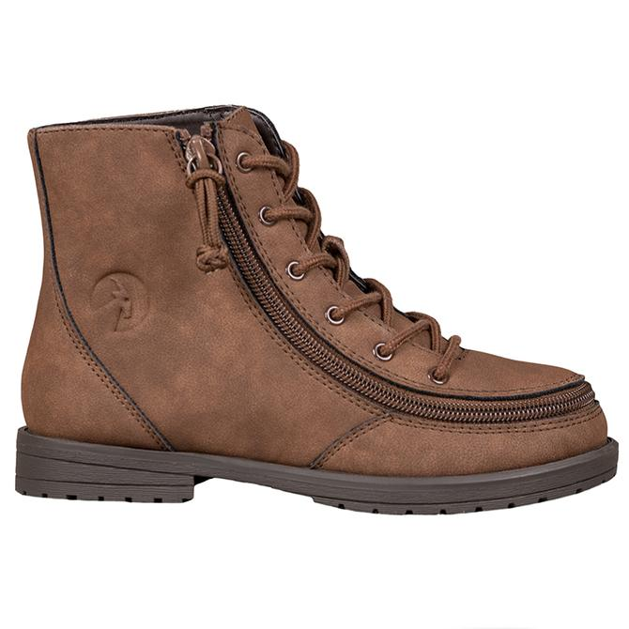 | 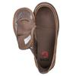
Surestep  - Designed for children who wear ankle braces. Has a wider, deeper heel, toe box, and instep which allows for adequate room and a comfortable fit. | 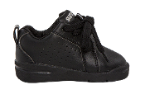
Stride Rite  - Ankle brace friendly shoes | 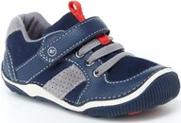
Apis shoes  - Designed to accommodate footwear needs for ankle braces | 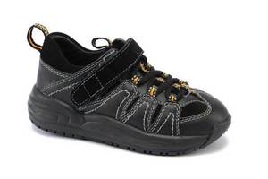
Nike FlyEase  - Version 1: unzip the zipper around the heel to open the heel cup  - Version 2: similar to the “Keeping Pace Shoes” | 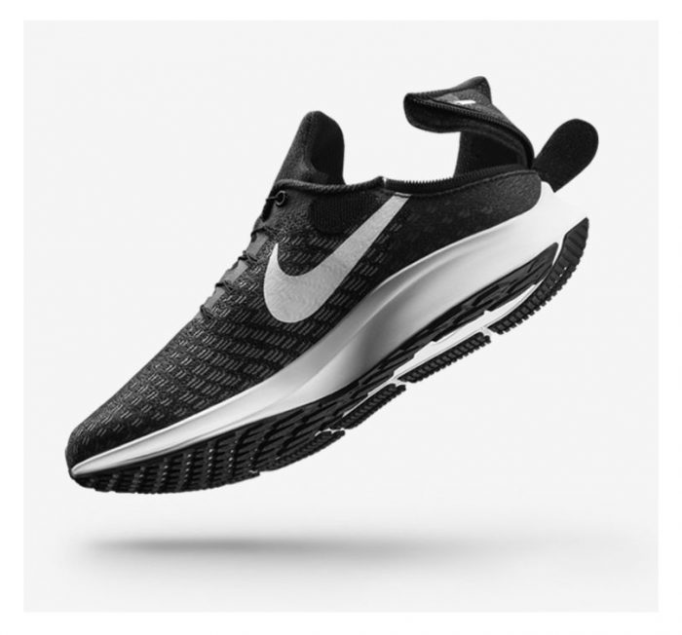 | 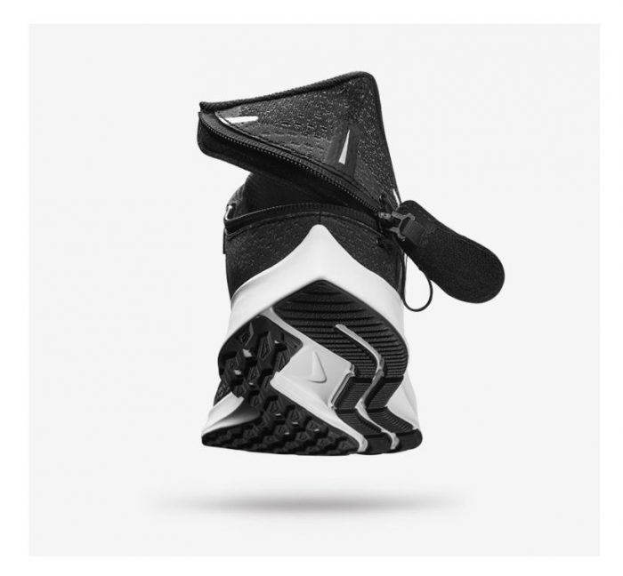
New Balance Shoes
- Have shoes available in wide widths
The Wide Shoes
- Shoes in wide widths
EasyUp shoes
- Not available in U.S. but maybe sometime in the future?

